

Test Discrepancy Report (TDR)

Cisco GCT DP Session Border Controller (SBC)
with Software Release IOS XE 17.12

TDR Number: 26003-01

Requirement: UCR 2013 Change 2, Section 2.25.1

Criticality: SCM-012040 [Required: AEI, SC, SS] [Optional: PEI]

Finding: MLPP CALL FAILS TO PRODUCE AUDIO UPON PREEMPTION

Description of product:
The Cisco Session Border Controller (SBC) facilitates IP to IP AS-SIP communications between session controllers (SC) that support the UCR Alternative B failover method and their end instruments, when traversing the UC Network. The SBC interfaces with DISN UC systems through an AS-SIP interface and provides IP to IP communications between edge (LSC/ESC) and core (Softswitch) segments in the UC network. Additional functions include AS-SIP Signaling and encryption services to allow end to end communications on the UC Network. This solution can also be combined with a Cisco Session Controller to provide both interworking and SBC capabilities. This SBC solution consists of the Cisco ISR 4000 series, ASR 1000 series, Catalyst 8000V, Catalyst 8200 Series and Catalyst 8300 Series of hardware platforms.

Problem Description:
Call string setup is achieved correctly; however, no audio is produced upon the preemption.

Condition of test:
Test Scenario:
A call C @ ROUTINE Precedence
A and C connect
B calls C @ PRIORITY Precedence

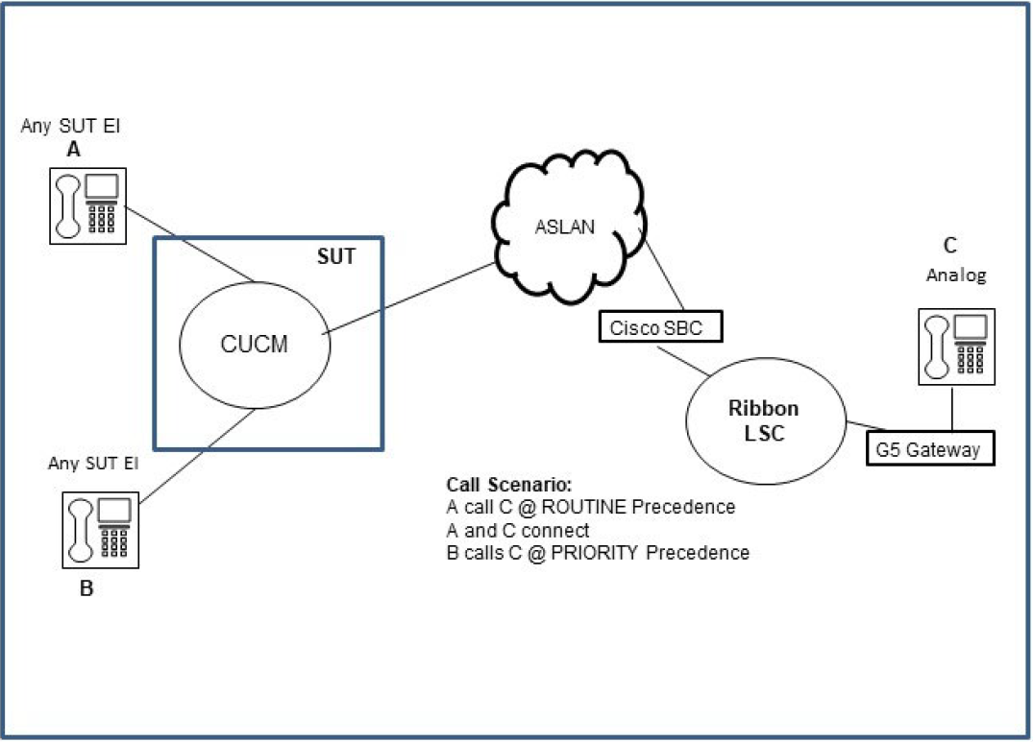

Figure 1: SUT Test Scenario

Test Result:
A and C both receive Precedence Notification Tone (PNT)
A and C go on hook
C rings @ Precedence cadence and goes off hook
B and C connect, but neither received any audio

Note: If either party does a hold off hold function, the audio is established.

Expected behavior:
After B and C connect, both parties should receive audio.

Components Affected: Cisco SBC23 (SC)

